**Foreword**

**I’m delighted to bring you our Rotherham Together Partnership annual report for 2023/24.**

Although the report can’t possibly capture everything that local partners are delivering, it provides a really good snapshot of the projects, programmes and initiatives that are making a tangible difference for our people and places.

The range of activity taking place across our priority themes is striking: from helping people into work and delivering regeneration schemes throughout the borough, to family hubs, tree planting and tackling hate crime.

Partnership working is integral to what we do in Rotherham. It is about making connections and building relationships; enabling us then to pool our skills, knowledge and resources so that we can make more of an impact.

This approach is ingrained through the strong structures we have in place. More simply though, it reflects an attitude. Organisations and staff at all levels and across all sectors want to support each other, learn from each other, and – together – do their absolute best to create a better borough for everyone.

**Councillor Chris Read, Chair of the Rotherham Together Partnership**

**Introduction**

**Rotherham Together Partnership comprises a range of partnership bodies and organisations from the public, private and voluntary and community sectors. Focusing on shared priorities set out in the Rotherham Plan 2025 and other thematic strategies, we combine our knowledge, skills and resources to deliver projects and initiatives that benefit local people and places.**

This annual report highlights the progress made over the last twelve months, with key achievements based around the five themes of the Rotherham Plan:

* Theme 1 A place to be proud of
* Theme 2 Inclusive economy
* Theme 3 Climate and environment
* Theme 4 Health and wellbeing
* Theme 5 Building stronger communities

As a partnership, we will continue to listen, engage and act together to improve our places and enable our residents to live healthy and fulfilling lives.

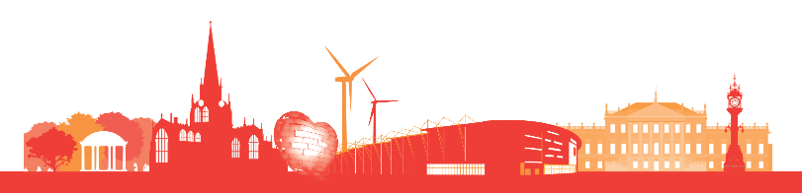

**Theme 1 – A place to be proud of**

Delivering regeneration across Rotherham, inspiring people and creating great places.

### Key projects

* 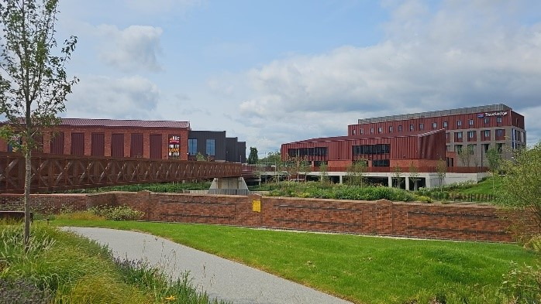**Opening of Grimm and Co’s** magical new base in the town centre, following an extensive refurbishment that has transformed an old church into a fantastical Emporium of Stories.
* **Regeneration schemes** to boost the visitor and leisure economy, with improvements at Magna and Maltby Academy completed,
* **Flagship town centre development** at Forge Island, comprising an eight-screen cinema and 69-room hotel.

**Theme 2 – Inclusive economy**

Creating opportunities for everyone to participate in and benefit from a growing economy.

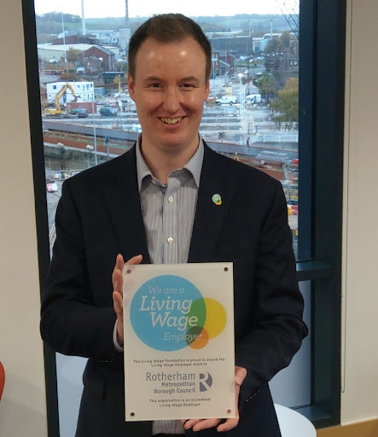**Key projects**

* **Joint initiatives and commitments on social value** **and promotion of the Real Living Wage**, including holding a social value celebration event for suppliers to showcase impact and inspire others.
* Delivery of a small business grants scheme and **opening of Century 2**, a new business centre at Manvers.
* Further external funding secured to continue our key **employment and skills projects**, including Employment Solutions; Ambition; and Advance



**Theme 3 – Climate and environment**

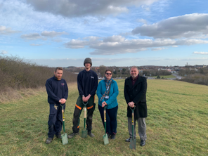Building a healthy and attractive local environment, whilst acting on the climate crisis.

**Key projects**

* Partners signed up to a **climate and nature charter**, which sets out 10 pledges on the net zero journey.
* A new community woodland has been created in Dinnington, where **7,700 trees have been planted** with funding from the Woodland Trust’s Grow Back Greener programme.
* The **Wath to Manvers** and **Broom Road cycleways** are complete.

**Theme 4 – Health and wellbeing**

Enabling people to lead healthy lives, tackling inequalities and focusing on prevention.

### Key projects

* **Implementation of ‘family hub’ approach** in children’s centres to provide integrated support to families, with up to 16 services now co-located in hubs across the borough.
* New diagnostic centre opened at **Badsley Moor Lane**, providing an out-patient respiratory and sleep physiology service.
* **Launched ‘Say Yes!**’, a new public health improvement and prevention campaign to provide advice on areas such as stopping smoking, tobacco control, food and physical activity.



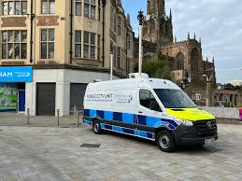**Theme 5 – Building stronger communities**

### Working with individuals and communities on the things that matter most to them.

### Key projects

### A new mobile CCTV unit to reduce crime and anti-social behaviour across the borough, targeting hotspot areas and open spaces, as well as being used for events.

### A range of safety improvements in Rotherham town centre, including new lighting at Snail Hill, a replacement fire door at Wellgate multi-storey car park and upgrades to the ‘shop link’ radios, which will help local businesses communicate with one another if an incident takes place.

### The Rotherham Show returned to Clifton Park in September 2023, offering free entertainment and family fun. New for 2023, the Festival Village, curated by Flux Rotherham, treated visitors to music from Rotherham Drummers United and The Bewonderment Machine, poetry from Ray Hearne, a wonderful workshop from artist and designer Ellie Way, and traditional dance by Wath Morris Minors.

